Chapter 9, Problem 81.

The ac bridge in Fig. 9.37 is balanced when R₁ = 400 Ω, R₂ = 600 Ω,
R₃ = 1.2 kΩ, and C₂ = 0.3 μ F. Find R_{x} and C_{x}. R_{z} and C_{z} are in series.

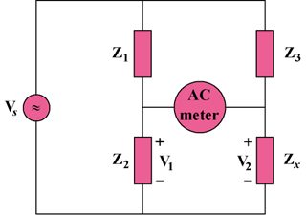

Figure 9.37
For Prob. 9.81.

